|  |
| --- |
|  |
| Retail Store Low Level Design |
|  |

Version control

|  |  |
| --- | --- |
| **Prepared by:** | Santosh kumar singh |
| **Date:** | Dec 10, 2019 |
| **Reviewed by:** |  |
| **Date:** |  |
| **Approved by:** |  |
| **Date:** |  |

# Executive Summary

## Introduction

The purpose of the document is to detail the requirements related to retail store. This has been done through

* Study of the requirements captured in SRS

LLD document includes

* Triggering Event
* Navigation
* Workflow
* User interface
* Attribute Usage
* Roles & Responsibilities
* Validation Messages

This document will now become the basis for the detailed design, development of application and the deployment thereof.

Any changes to this document once signed off will be controlled through change request process defined for the retail store.

## Overview

* Retail Store - is a process for capturing the detailed information of groceries.

## Scope

This document will provide details on the following areas:

* Process Flows

• Process Designs Patterns

• User interface

## Business Requirements

Please refer to Retail Store Information System Requirements Specification for business requirements.

## Assumptions

NA

# Retail Management – Process Flow and Functionality

Retail Management system comprises of following processes.

## Process#1 – Retail Store

### Retail Store

#### Triggering Event

The process will start when employee of Retail Store will click on the menu link Retail -> Store-> Create Retail groceries store.

#### Navigation

|  |  |  |
| --- | --- | --- |
| Retail | Retail Store | Create Groceries store |
|  |  | Search |
|  |  | Tasklist |

Retail-> Retail Store-> Create Groceries Store

#### Workflow

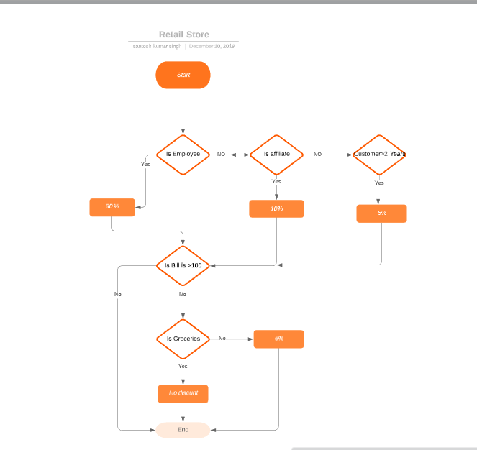

#### Interfacing system Details

NA

#### Design Consideration

**NA**

#### Solution Overview

**NA**

#### Forms

#### New Create Groceres Store

This form will be used to create groceries store.

##### Property Sheet

|  |  |  |  |  |  |  |  |  |  |  |  |
| --- | --- | --- | --- | --- | --- | --- | --- | --- | --- | --- | --- |
| **Field Name** | **Req** | **Type** | **Data Type** | **Master Data** | **Min Len** | **Max Len** | **Validation ID** | | **Action Event** | **Visibility Criteria** | **Enablement Criteria** |
| Bill Numer | Yes | Textbox | String | None | 1 | 50 | Val1 | | NA | Yes | Yes |
| Bill Date | Yes | Textbox | String | None | NA | NA | NA | | NA | Yes | No |
| Groceries Item | Yes | Drop Down | String | item Master | NA | NA | Val1 | | NA | Yes | Autopopulated,Yes |
| Quantity | Yes | Textbox | String | None | NA | NA | NA | | NA | Yes | No |
| Customer phone number | Yes | Textbox | String | None | NA | NA | NA | | NA | Yes | No |
| Save | NA | Command Button | NA | None | NA | NA | NA | | New joining details saved in the database. | Invisible after Successful submit.  Visible before Successful submit | Yes |
| Submit | NA | Command Button | NA | None | NA | NA | NA | New Joining details saved in the database and submitted to approvers. | | Invisible after Successful submit.  Visible before Successful submit | Yes |

#### Validation Messages

NA

#### Localization

NA

#### Integration

NA

#### Reports

NA